**Laserilla toimiva ajanotto laite**

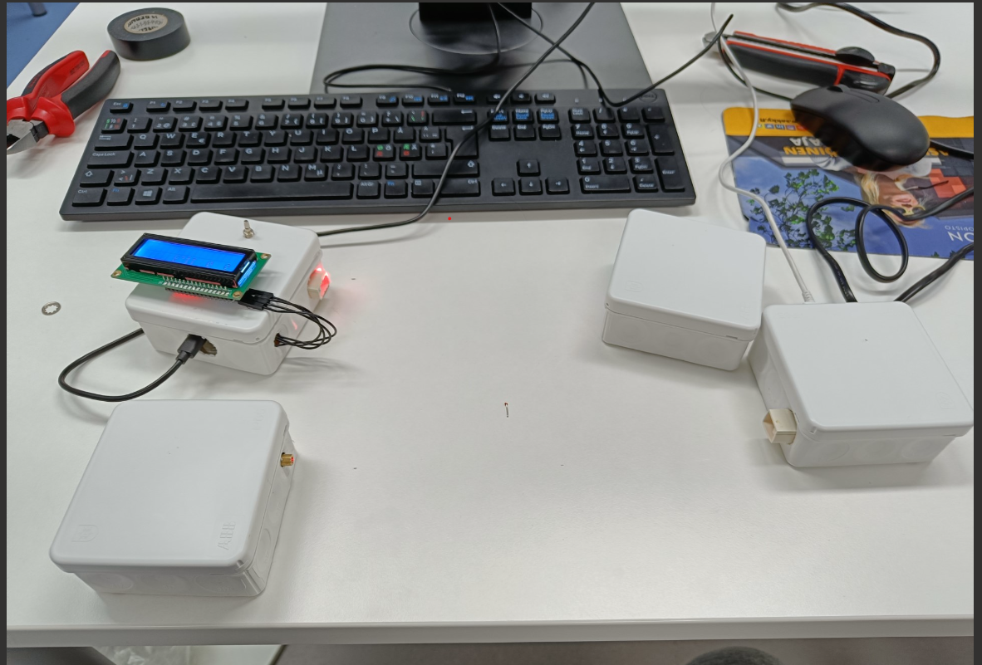

Näyttötyö:

Valtteri Kinnunen K3TVT21C

Savon ammattiopisto

**Johdanto**

Tässä työssä oli tarkoituksena rakentaa ja ohjelmoida ajanotto laite. Aika alkaa, kun laser katkaistaan ja loppuu kun toinen laser katkaistaan. Aika näytetään lcd näytöllä. Työssä on lähtö viiva laser ja loppuviiva laser. Laitteet käyttävät laser moduleja ja ldr vastuksia tunnistamaan laserin valoa.

**Tarvikeluettelo**

|  |  |  |
| --- | --- | --- |
|  | kpl | hinnasto |
| esp32 | 2 |  |
| laser module | 2 |  |
| ldr | 2 |  |
| lcd i2c näyttö | 1 |  |
| nappi | 1 |  |
| akku | 4 |  |
| 10komh vastus | 3 |  |

**Ohjelmointityökalujen käyttöönotto**

Asenna Arduino IDE

<https://www.arduino.cc/en/software>

Asenna CP2014 USB ajuri

<https://learn.adafruit.com/adafruit-huzzah32-esp32-feather/using-with-arduino-ide>

Asenna Adafruit Huzzah with ESP32 kirjastot Arduino Ideen

Lisää tämä rivi Arduino Iden asetuksiin: https://dl.espressif.com/dl/package_esp32_index.json

(<https://raw.githubusercontent.com/espressif/arduino-esp32/gh-pages/package_esp32_index.json>)

Asenna Boards Managerissa esp32 korttipaketti Arduino Ideen

Valitse Arduino Idessä kortti Adafruit ESP32 Feather

**Johdotuskaavio**

Lähettäjä:

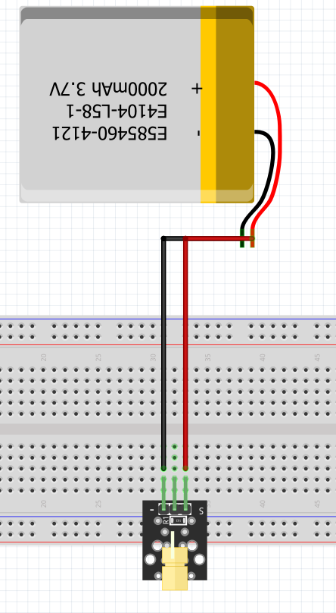

Vastaanotin:

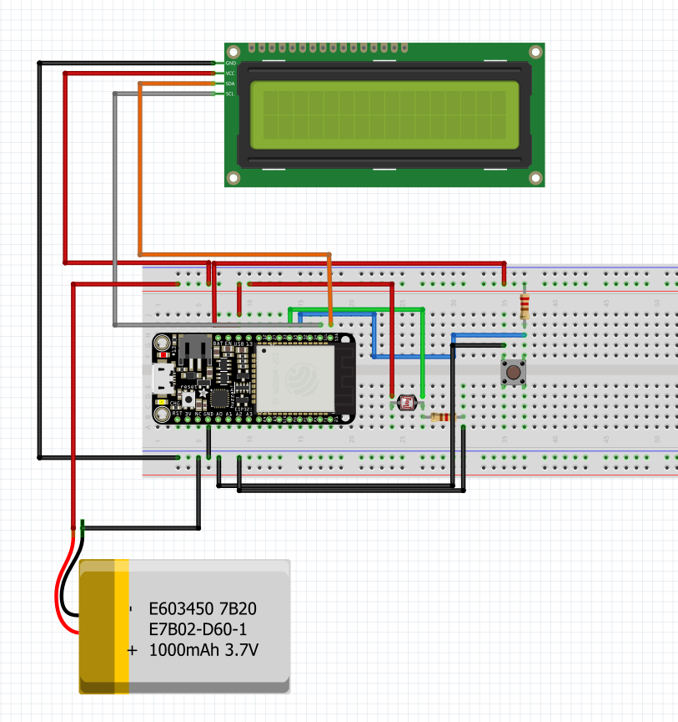

**Johdotus kaavio:**

Lähetin

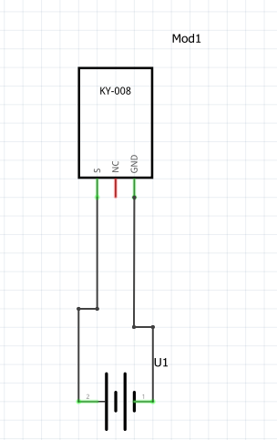

vastaanotin:

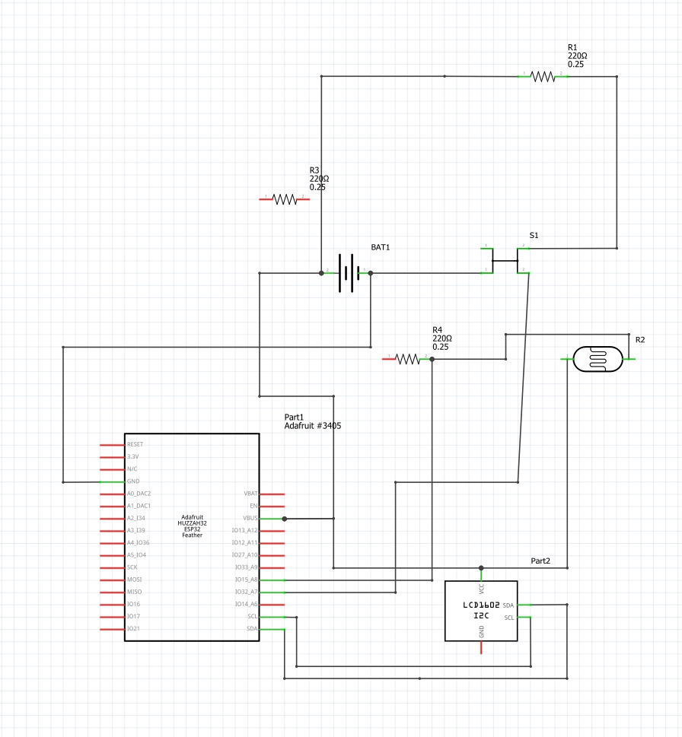

**Ohjelmointi:**

käytetyt kirjastot

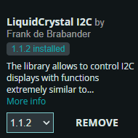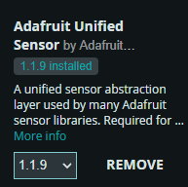

lähettäjä:

#define BLYNK_TEMPLATE_ID "TMPL4dw-oY_P3"

#define BLYNK_TEMPLATE_NAME "timer"

#define BLYNK_AUTH_TOKEN "46N-ZnxgEH256kKS1vbh0jxBEbkugVzP"

#define BLYNK_PRINT Serial

#include <WiFi.h>

#include <esp_now.h>

#include <WiFiClient.h>

#include <BlynkSimpleEsp32.h>

#include <Adafruit_Sensor.h>

uint8_t broadcastAddress[] = {0x3C, 0x71, 0xBF, 0x6F, 0x32, 0x70};

// Your WiFi credentials.

// Set password to "" for open networks.

char ssid[] = "TVT-WLAN";

char pass[] = "salasana";

int pin = 33;

int sensorValue;

int StartTimer = 0;

String success;

typedef struct struct_message{

  float Start;

} struct_message;

struct_message SendTimer;

esp_now_peer_info_t peerInfo;

void OnDataSent(const uint8_t *mac_addr, esp_now_send_status_t status) {

  Serial.print("\r\nLast Packet Send Status:\t");

  Serial.println(status == ESP_NOW_SEND_SUCCESS ? "Delivery Success" : "Delivery Fail");

  if(status == 0){

    success = "Delivery Success :)";

    Serial.println(StartTimer);

  }

  else{

    success = "Delivery Fail:(";

  }

}

void setup() {

  // put your setup code here, to run once:

  Serial.begin(115200);

  // Set device as a Wi-Fi Station

  WiFi.mode(WIFI_MODE_STA);

  // Init ESP-NOW;

  Serial.print(WiFi.macAddress());

  if(esp_now_init() != ESP_OK) {

    Serial.print("Error initializing ESP-NOW");

    return;

  }

  // Once ESPNow is successfully Init, we will register for Send CB to

  // get the status of Trasnmitted packet

  esp_now_register_send_cb(OnDataSent);

  //register peer

  esp_now_peer_info_t peerInfo;

  memset(&peerInfo, 0, sizeof(peerInfo));

  memcpy(peerInfo.peer_addr, broadcastAddress, 6);

  peerInfo.channel = 0;

  peerInfo.encrypt = false;

  // add peer

  if(esp_now_add_peer(&peerInfo) != ESP_OK){

    Serial.println("failed to add peer");

    return;

  }

}

void loop() {

  // put your main code here, to run repeatedly:

  //reads ldr value

  sensorValue = analogRead(pin);

  Serial.println(sensorValue);

  //if ldr value is less the 3000 if it is starts timer

  if(sensorValue < 3000){

      StartTimer = 1;

      SendTimer.Start = StartTimer;

      Serial.println(StartTimer);

  }

  else{

    StartTimer = 0;

    SendTimer.Start = 0;

  }

  esp_err_t result = esp_now_send(broadcastAddress, (uint8_t *) &SendTimer, sizeof(SendTimer));

  if(result == ESP_OK) {

    //Serial.println("Sent with success");

  }

  else {

    Serial.println("Error sending the data 1");

  }

  delay(500);

}

vastaanottaja:

#define BLYNK_TEMPLATE_ID "TMPL4dw-oY_P3"

#define BLYNK_TEMPLATE_NAME "timer"

#define BLYNK_AUTH_TOKEN "46N-ZnxgEH256kKS1vbh0jxBEbkugVzP"

#define BLYNK_PRINT Serial

#include <WiFi.h>

#include <esp_now.h>

#include <WiFiClient.h>

#include <BlynkSimpleEsp32.h>

#include <Adafruit_Sensor.h>

#include <LiquidCrystal_I2C.h>

uint8_t broadcastAddress[] = {0xCC, 0x50, 0xE3, 0xBB, 0xE7, 0x84};

// Your WiFi credentials.

// Set password to "" for open networks.

char ssid[] = "TVT-WLAN";

char pass[] = "salasana";

LiquidCrystal_I2C lcd(0x3F, 16, 2);

BlynkTimer timer;

int pin = 33;

int sensorValue;

int crossed = 0;

int last = 0;

int stop = 1;

int StartTimer = 0;

int TimerStarted = 0;

unsigned long Timer;

unsigned long StartTime;

unsigned long elapsedTimemS;

unsigned long elapsedTimeS;

unsigned long elapsedTimeM;

unsigned long elapsedTimeH;

typedef struct struct_message{

  float Start;

} struct_message;

struct_message ReadStart;

void DataRecieved(const uint8_t * mas, const uint8_t *incomingData, int len) {

  memcpy(&ReadStart, incomingData, sizeof(ReadStart));

  /*Serial.print("Recieved data: ");

  Serial.println(len);

  Serial.print("StartTimer: ");

  Serial.println(ReadStart.Start);*/

  StartTimer = ReadStart.Start;

}

void setup() {

  // put your setup code here, to run once:

pinMode(32, INPUT_PULLUP);

  Serial.begin(115200);

  WiFi.mode(WIFI_MODE_STA);

  Serial.print(WiFi.macAddress());

  elapsedTimeS = 0;

  //initializing lcd

  lcd.init();

  lcd.clear();

  lcd.backlight();

  //Blynk.begin(BLYNK_AUTH_TOKEN, ssid, pass);

  //timer.setInterval(1000L, myTimerEvent);

  if(esp_now_init() != ESP_OK){

    Serial.println("Error: connection failed");

    return;

  }

  esp_now_peer_info_t peerInfo;

  memset(&peerInfo, 0, sizeof(peerInfo));

  memcpy(peerInfo.peer_addr, broadcastAddress, 6);

  peerInfo.channel = 0;

  peerInfo.encrypt = false;

  if(esp_now_add_peer(&peerInfo) != ESP_OK){

    Serial.println("Error adding reciever");

    return;

  }

  esp_now_register_recv_cb(DataRecieved);

}

void loop() {

  // put your main code here, to run repeatedly:

  int button32 = digitalRead(32);

  //reads ldr value

  sensorValue = analogRead(pin);

  //Blynk.run();

  //timer.run();

  last = crossed;

 if(StartTimer == 1){

    Timer = millis();

    TimerStarted = 1;

  }

  //Serial.println(StartTimer);

  if(sensorValue > 0){

    crossed = 0;

  }

  else{

    crossed = 1;

  }

  //start a timer

  StartTime = millis();

  //checks if ldr value is 4000 or over

  if(sensorValue >= 4000){

    stop = 1;

  }

  //if ldr value is less the 3000 if it is starts timer

  else if(sensorValue < 3000){

    //Timer = millis();

    //if timer has started stops the timer when the laser is triggered

   if(TimerStarted == 1 && stop == 1){

     TimerStarted = 0;

     stop = 0;

   }

  }

  //delay(500);

  if(TimerStarted == 1){

    //calculates how long it has been after the laser was triggered in seconds

    //elapsedTimeS = (StartTime - Timer) / 1000;

    //calculates how long it has been after the laser was triggered in tenths of seconds

    elapsedTimemS = (StartTime - Timer) / 100;

    if(elapsedTimemS >= 10){

      elapsedTimemS = 0;

      elapsedTimeS++;

      lcd.clear();

      Timer = millis();

    }

    //changes second to minutes

    if(elapsedTimeS == 60){

      elapsedTimeM++;

      elapsedTimeS = 0;

      lcd.clear();

    }

    //changes minutes to hours

    if(elapsedTimeM == 60){

      elapsedTimeH++;

      elapsedTimeM = 0;

    }

  }

  lcd.setCursor(0, 0);

  lcd.print(elapsedTimeH);

  lcd.setCursor(3, 0);

  lcd.print(elapsedTimeM);

  lcd.setCursor(6, 0);

  lcd.print(elapsedTimeS);

  lcd.setCursor(8, 0);

  lcd.print(".");

  lcd.setCursor(9, 0);

  lcd.print(elapsedTimemS);

  if(button32 == LOW){

    TimerStarted = 0;

    elapsedTimeH = 0;

    elapsedTimeM = 0;

    elapsedTimeS = 0;

    elapsedTimemS = 0;

    lcd.clear();

    lcd.setCursor(0, 0);

    lcd.print(elapsedTimeH);

    lcd.setCursor(3, 0);

    lcd.print(elapsedTimeM);

    lcd.setCursor(6, 0);

    lcd.print(elapsedTimeS);

    lcd.setCursor(7, 0);

    lcd.print(".");

    lcd.setCursor(8, 0);

    lcd.print(elapsedTimemS);

  }

}

**Johtopäätökset ja itsearviointi**

Työ ei ollut erityisen vaikea mutta joiduin kysymään aika paljon apua.

Työhön olisi voinut lisätä ilmoituksen, kun akku oli lopussa ja tiedon olisi voinut jakaa eri tavalla jotta ajan olisi voinut näyttää blynkissä.

Antaisin työstä arvosanan 3